ECA5604- 5g/6g communication
Slot A
M.Pregna
192412350

Ex.No. 12: NB-IoT vs LTE-M Throughput Simulation
AIM: To simulate and compare the performance of NB-IoT and LTE-M communication
technologies in terms of Throughput (Mbps), Latency (ms), and Packet Delivery Ratio (%)
using MATLAB..
Objective 1:
code:
clc;
clear;
close all;
% SNR values (dB)
SNR = 0:5:30;
% Simulated Throughput (Mbps)
NB_IoT = 0.05*(1-exp(-SNR/8));
LTE_M = 1.2*(1-exp(-SNR/8));

disp('SNR (dB) NB-IoT(Mbps) LTE-M(Mbps)')
disp([SNR' NB_IoT' LTE_M'])
figure
% -------- Graph 1 --------
subplot(2,1,1)
plot(SNR,NB_IoT,'-o','LineWidth',2)
title('NB-IoT Throughput vs SNR')
xlabel('Signal-to-Noise Ratio (dB)')
ylabel('Throughput (Mbps)')
grid on
% -------- Graph 2 --------
subplot(2,1,2)
plot(SNR,LTE_M,'-s','LineWidth',2)
title('LTE-M Throughput vs SNR')
xlabel('Signal-to-Noise Ratio (dB)')
ylabel('Throughput (Mbps)')
grid on

output:
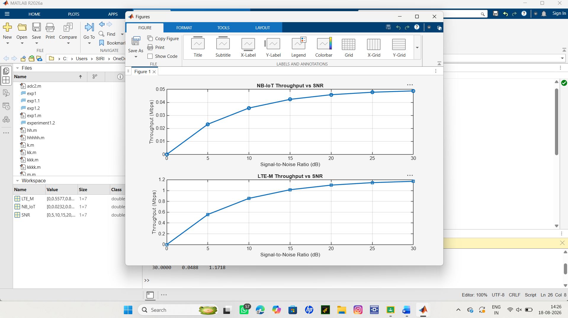

Objective 2:
Code:
clc;
clear;
close all;
% SNR values (dB)
SNR = 0:5:30;
% Simulated Latency (ms)
NB_IoT = [180 160 145 130 120 110 100];
LTE_M = [90 80 70 60 50 45 40];
disp('SNR(dB) NB-IoT Latency(ms) LTE-M Latency(ms)')
disp([SNR' NB_IoT' LTE_M'])
figure
% -------- Graph 1 --------
subplot(2,1,1)
plot(SNR,NB_IoT,'-o','LineWidth',2)
title('NB-IoT Latency vs SNR')
xlabel('Signal-to-Noise Ratio (dB)')
ylabel('Latency (ms)')
grid on
% -------- Graph 2 --------
subplot(2,1,2)
plot(SNR,LTE_M,'-s','LineWidth',2)
title('LTE-M Latency vs SNR')
xlabel('Signal-to-Noise Ratio (dB)')
ylabel('Latency (ms)')
grid on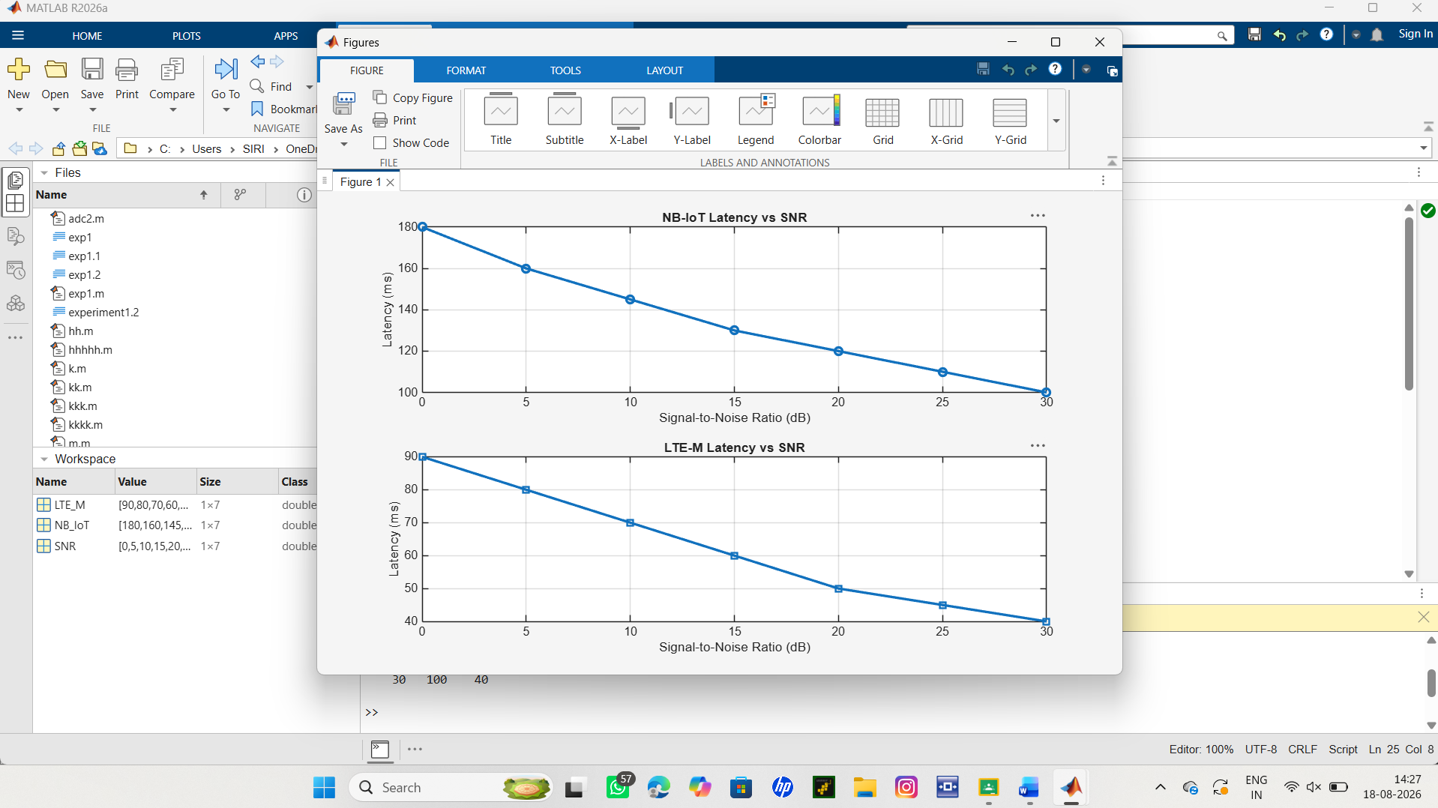
Objective 3:
Code:
clc;
clear;
close all;
% SNR values (dB)
SNR = 0:5:30;
% Simulated Packet Delivery Ratio (%)
NB_IoT = [82 86 89 92 95 97 99];
LTE_M = [88 91 94 96 98 99 100];
disp('SNR(dB) NB-IoT PDR(%) LTE-M PDR(%)')
disp([SNR' NB_IoT' LTE_M'])
figure
% -------- Graph 1 --------
subplot(2,1,1)
plot(SNR,NB_IoT,'-o','LineWidth',2)
title('NB-IoT Packet Delivery Ratio vs SNR')
xlabel('Signal-to-Noise Ratio (dB)')
ylabel('Packet Delivery Ratio (%)')
grid on
% -------- Graph 2 --------

subplot(2,1,2)
plot(SNR,LTE_M,'-s','LineWidth',2)
title('LTE-M Packet Delivery Ratio vs SNR')
xlabel('Signal-to-Noise Ratio (dB)')
ylabel('Packet Delivery Ratio (%)')
grid onoutput:
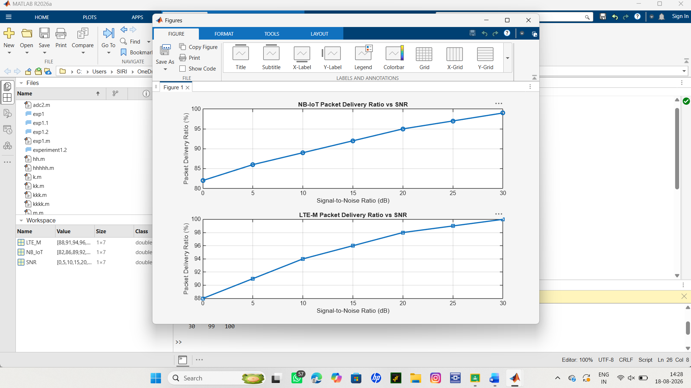

Result:
The Packet Delivery Ratio (PDR) of both NB-IoT and LTE-M increases as the Signal-to-Noise
Ratio (SNR) improves. LTE-M achieves a slightly higher PDR than NB-IoT, indicating more
reliable packet transmission under the same channel conditions.

